Video No. P 1007
 | Slide : 1 (Our Wedding Invirtation)  Save the Date :
  05 March 2018

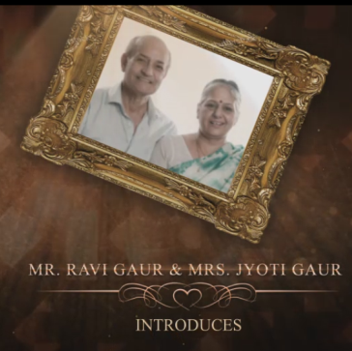 | Slide : 2 (Parents Name)  Introduces
  Mr. Ravi Gaur & Mrs. Jyoti Gaur

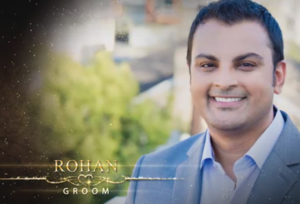 | Slide : 3 (Groom Photograph & Name)  (High Resolution : Minimum 800 x 800 pixel)  Please rename your photograph with the name of Slide 3  Send your photograph by E-mail  Groom Name :  (If you are from bride side so first photo will come Bride photo and from groom side so first photo will come groom photo)
  Rohan

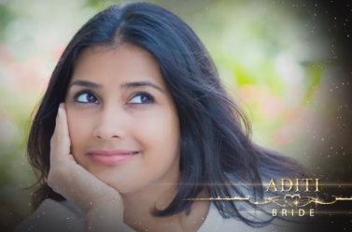 | Slide : 4 (Bride Photograph & Name)  (High Resolution : Minimum 800 x 800 pixel)  Please rename your photograph with the name of Slide 4  Send your photograph by E-mail  Groom Name :
  Aditi

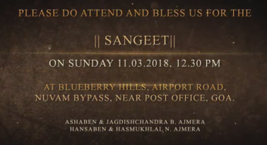 | Slide : 5 (Function Detail)  Function Name  Function Date :  Function Time :  Venue:
  Sangeet
  On Sunday 11.03.2017
  At 12.30 pm
  At Blueberry Hills, Airport Road, Nuvam Baypass, Near Post Office, Goa.

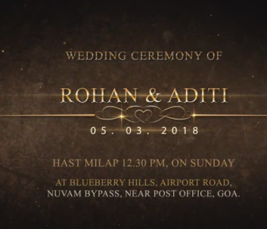 | Slide : 6 (Function Detail)  Wedding Ceremony of  Couple Name  Function Date :  Function Time :  Venue:
  Rohan & Aditi
  05.03.2018 Sunday
  Hast Melap 12.30 pm
  At Blueberry Hills, Airport Road, Nuvam Baypass, Near Post Office, Goa.

Video Music :
Same As or If any choice please send me Youtub Link by mail and Mention in form also.
Link :
Same As

