Video No. P 1201
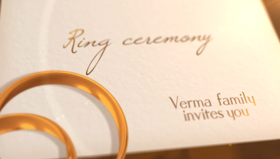 | Slide No. 1 (Ring Ceremony)  Family Name  Invites you
  Verma Family

Slide No. 2
Couple Name
Shruti & Ronak

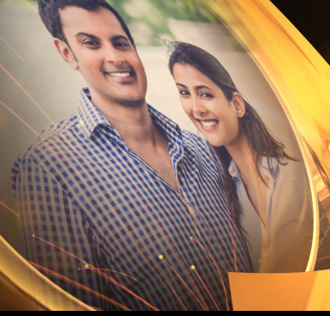 | Slide No. 3  Couple Photograph  (High Resolution : Minimum 800 x 800 pixel)  Please rename your photograph with the name of Slide 1  Send your photograph by E-mail

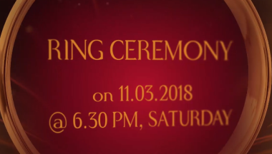 | Slide No. 4 (Function Detail)  Function Name  Function Time :  Function Date :
  Ring Ceremony
  At 6.30 pm
  Saturday, 11.03.2018

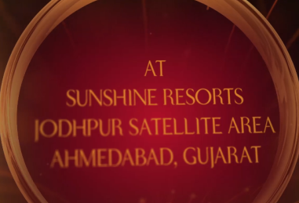 | Slide No. 5 (Function Detail)  Function Name  Function Time :  Function Date :  Venue:
  Sangeet
  At 6.30 pm
  Saturday 10.03.2018
  At Sunshine Resorts
  Jodhpur Satellite Area
  Ahemdabad, Gujarat.

Slide No. 6
Save The Date
11th march 2018

Video Music :
Same As or If any choice please send me Youtub Link by mail and Mention in form also.
Link :

