Video No.: P 1202
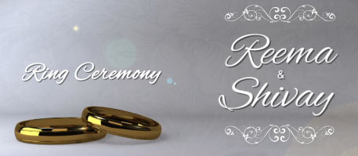 | Slide : 1 (Ring Ceremony)  Couple Name
  Reema & Shivay

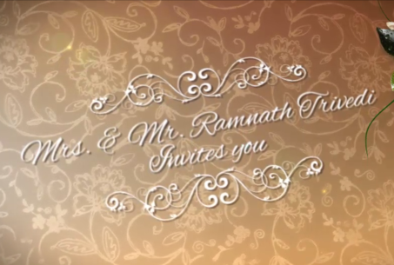 | Slide : 2  Invites you
  Mr. & Mrs. Ramnath Trivedi

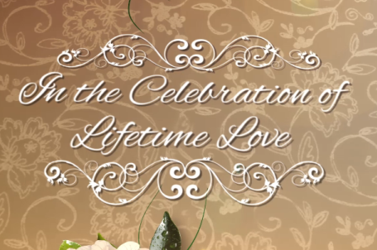 | Slide : 3  In the celebration of Lifetime Love

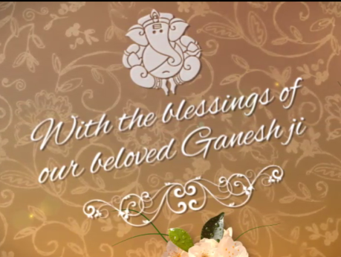 | Slide : 4  With the blessings of
  our beloved Ganeshji

 | Slide : 5 (Couple Photograph & Name)  (High Resolution : Minimum 800 x 800 pixel)  Please rename your photograph with the name of Slide 4  Send your photograph by E-mail  Couple Name
  Reema weds Shivay

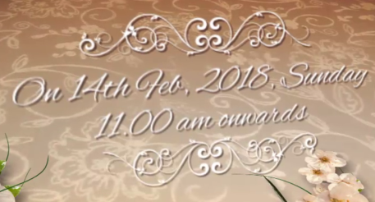 | Slide : 5 (Wedding Date & Time)  Date & Time
  on 14th Feb, 2018, Sunday
  11.00 am onwards

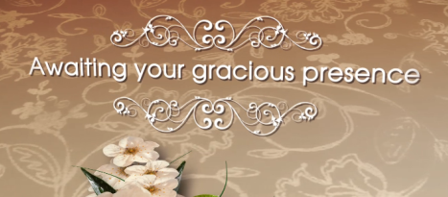 | Slide : 6 (Function Detail)  Awaiting your gracious presence

 | Slide : 10 (Save the date)  Date :
  Feb 14, 2018

Video Music :
Same As or If any choice please send me Youtub Link by mail and Mention in form also.
Link :
https://www.youtube.com/watch?v=nIhijSP3MBc

