Video No. P 1204
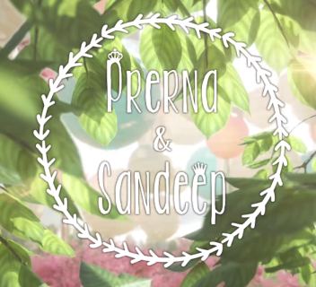 | Slide : 1 (Couple Name & Date)  Couple name
  Prerna & Sandeep

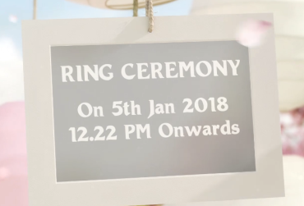 | Slide : 2  Ring Ceremony
  On 5th Jan. 2018 12.22 pm onwards

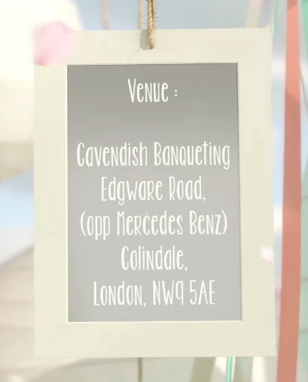 | Slide : 3 (Venue)  Venue
  Cavendish Banqueting, Edgware Road, (Opp. Mercedes Benz) Colindale, London, NW95AE

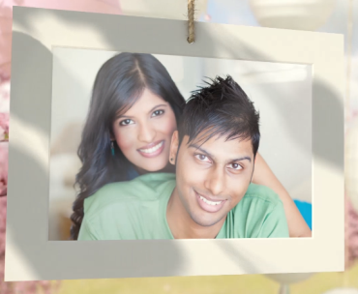 | Slide : 4 (Couple Photograph)  (High Resolution : Minimum 800 x 800 pixel)  Please rename your photograph with the name of Slide 4  Send your photograph by E-mail

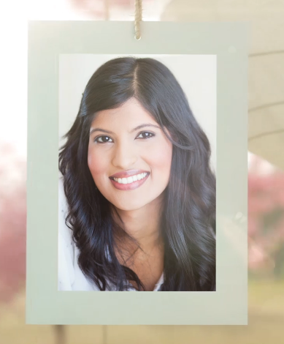 | Slide : 5 (Bride Photograph)  (High Resolution : Minimum 800 x 800 pixel)  Please rename your photograph with the name of Slide 5  Send your photograph by E-mail

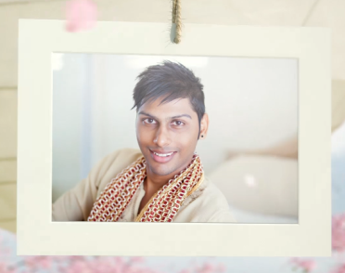 | Slide : 6 (Groom Photograph)  (High Resolution : Minimum 800 x 800 pixel)  Please rename your photograph with the name of Slide 6  Send your photograph by E-mail

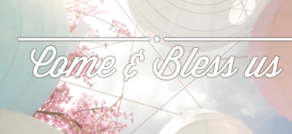 | Slide : 7  Come & Bless us

 | Slide : 8  (Save the Date)  Date
  05th January 2018

Video Music :
Same As or If any choice please send me Youtub Link by mail and Mention in form also.
Link :

