Video No. P 1206
 | Slide : 1  Ring Ceremony

 | Slide : 2  Couple Photograph  (High Resolution : Minimum 800 x 800 pixel)  Please rename your photograph with the name of Slide 1  Send your photograph by E-mail  Couple name  Date
  Rohan & Ashika
  05.03.2018

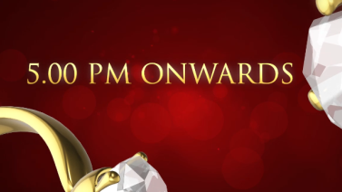 | Slide : 3  Time
  5.00 pm onwards

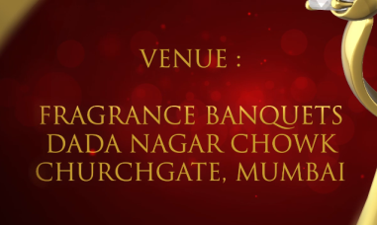 | Slide : 4  Venue  Fragrance banquets  Dada Nagar Chowk,  Churchgate, Mumbai.

 | Slide : 5  Save the Date
  05.03.2018

 | Slide : 6  Awaiting your gracious presence

Video Music :
Same As or If any choice please send me Youtub Link by mail and Mention in form also.
Link :

