Video No. P 1103
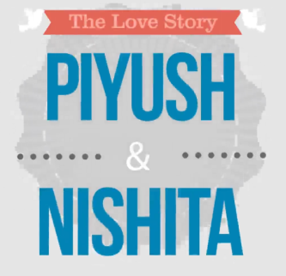 | Slide : 1  The love Story of  Couple name
  Piyush & Nishita

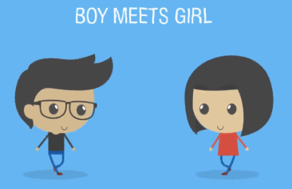 | Slide : 2  Boy Meets Girl

 | Slide : 3  Visit Places

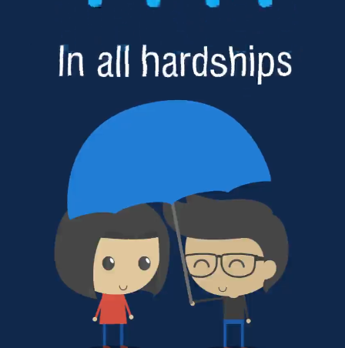 | Slide : 4  In all hardships

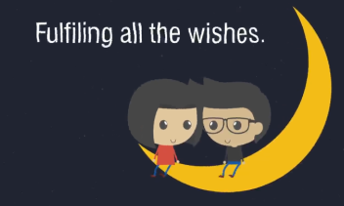 | Slide : 5  Fulfiling all the wishes

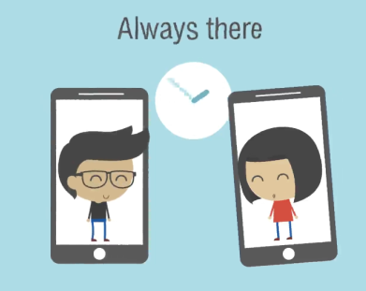 | Slide : 6  Always there

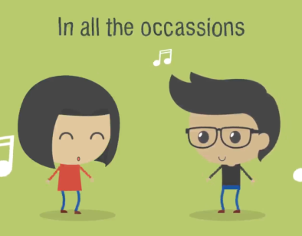 | Slide : 7  In all the occasions

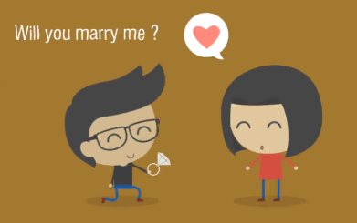 | Slide : 8  Will you marry me?

 | Slide : 9  Couple Name
  Piyush & Nishita

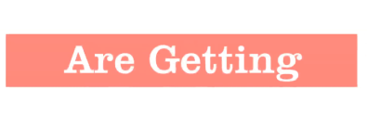   | Slide : 10  Are Getting  Married

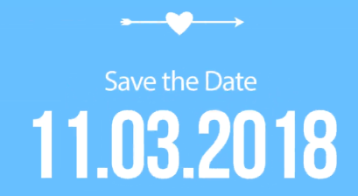 | Slide : 11  Save the Date
  11.03.2018

Video Music :
Same As or If any choice please send me Youtub Link by mail and Mention in form also.
Link :

