Video No. P 1103
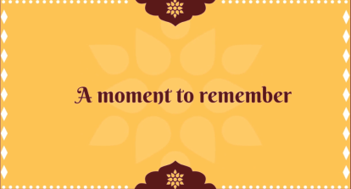 | Slide : 1  A moment to remember

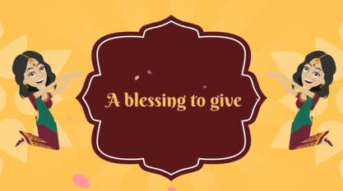 | Slide : 2  A blessing to give

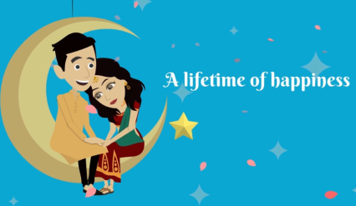 | Slide : 3  A lifetime of happiness

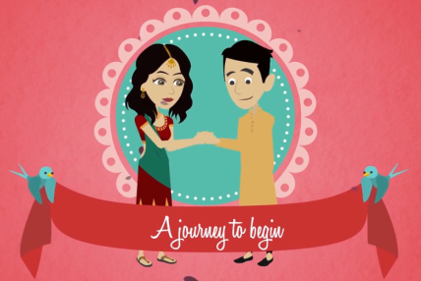 | Slide : 4  A journey to begin

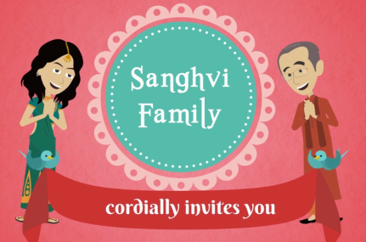 | Slide : 5  Cordially invites you
  Sanghvi Family

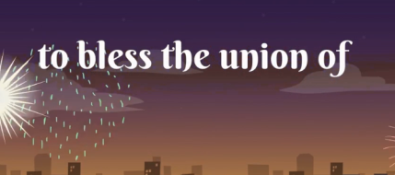 | Slide : 6  To bless the union of

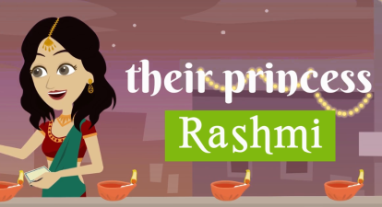 | Slide : 7  Their princess
  Rashmi

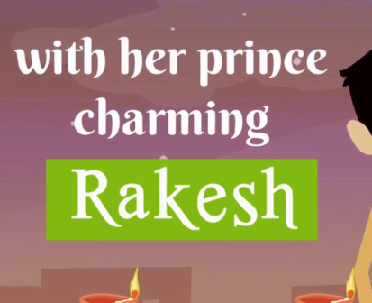 | Slide : 7  With her prince charming
  Rakesh

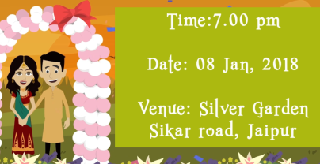 | Slide : 8  Time  Date:  Venue :
  7.00 pm
  08 jan. 2018
  Silver garden Sikar Road, jaipur.

Video Music :
Same As or If any choice please send me Youtub Link by mail and Mention in form also.
Link :

