Video No. P 1104
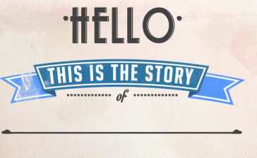 | Slide : 1  Hello  This is the Story  of

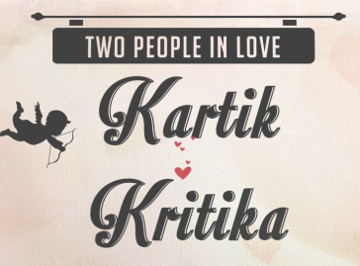 | Slide : 2  Two People in love  Couple name
  Kartik - Kritika

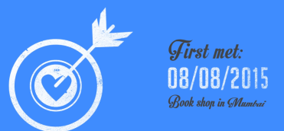 | Slide : 3  First Met:  Place
  08/08/2015
  Book Shop in Mumbai

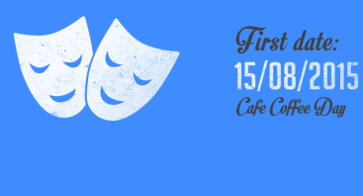 | Slide : 4  First Date:  Place
  15/08/2015
  Café coffee Day

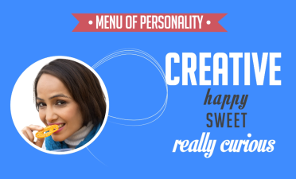 | Slide : 5  Menu of Personality  Bride Photograph  Creative  Happy Sweet  Really curious

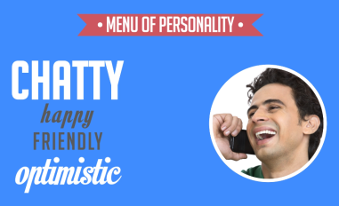 | Slide : 6  Menu of Personality  Groom Photograph  Chatty  Happy Friendly  optimistic

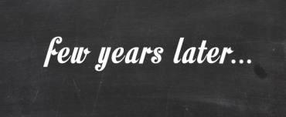 | Slide : 7  Few years later

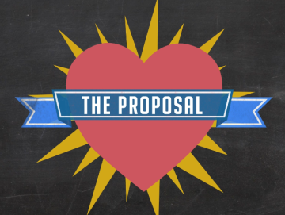 | Slide : 8  The proposal

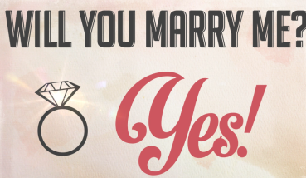 | Slide : 9  Will you marry me?  Yes!

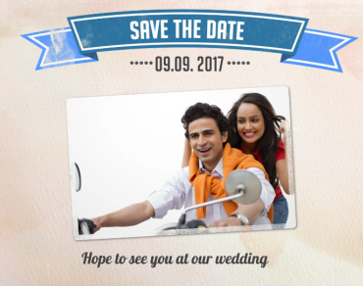 | Slide : 10  Save the date  Couple Photograph  Hope to see you at our wedding
  09.09.2017

Video Music :
Same As or If any choice please send me Youtub Link by mail and Mention in form also.
Link :

