Video No. P 1105
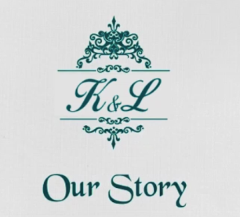 | Slide : 1  Couple’s Initial  Our Story
  K & L

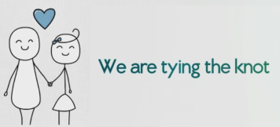 | Slide : 2  We are tying the knot

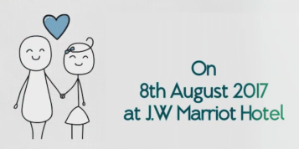 | Slide : 3  Date  Venue
  On 8th August 2017
  At J. W. Marriot Hotel

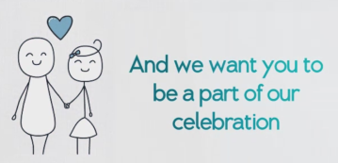 | Slide : 4  And we want you to be a part of our celebration

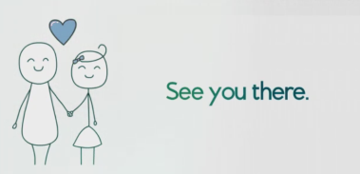 | Slide : 5  See you there

Video Music :
Same As or If any choice please send me Youtub Link by mail and Mention in form also.
Link :

