Video No. : 1012
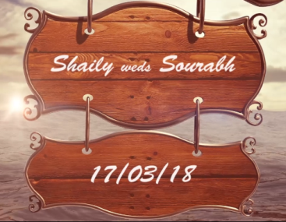 | Slide No. 1 (Couple Name & Date)  Couple Name  Date
  Shaily weds Saurabh
  17/3/2018

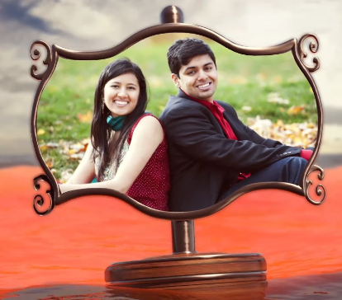 | Slide : 2 (Couple Photograph)  (High Resolution : Minimum 800 x 800 pixel)  Please rename your photograph with the name of Slide 2  Send your photograph by E-mail

 | Slide : 3 (Couple Photograph)  (High Resolution : Minimum 800 x 800 pixel)  Please rename your photograph with the name of Slide 3  Send your photograph by E-mail

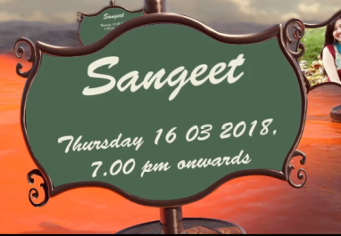 | Slide : 4 (Function Detail)  Function Name  Date  Time
  Sangeet
  Thursday, 16.03.2018
  7.00 pm Onwards

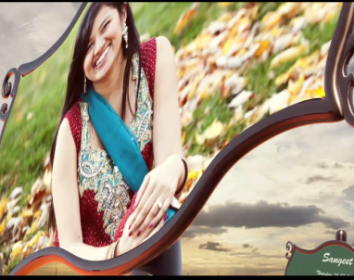 | Slide : 5 (Bride Solo Photograph)  (High Resolution : Minimum 800 x 800 pixel)  Please rename your photograph with the name of Slide 5  Send your photograph by E-mail

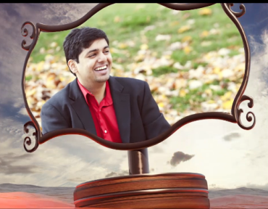 | Slide : 6 (Groom Solo Photograph)  (High Resolution : Minimum 800 x 800 pixel)  Please rename your photograph with the name of Slide 6  Send your photograph by E-mail

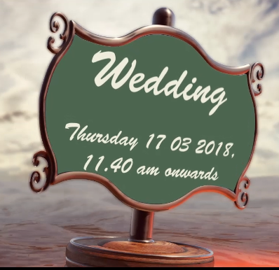 | Slide : 7 (Function Detail)  Function Name  Date  Time
  Wedding
  Friday, 17.03.2018
  11.40 am Onwards

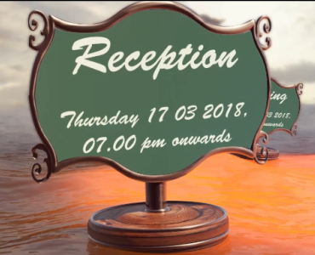 | Slide : 8 (Function Detail)  Function Name  Date  Time
  Reception
  Friday, 17.03.2018
  7.00 pm Onwards

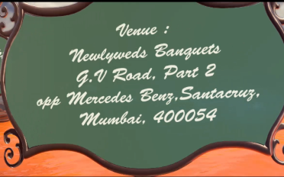 | Slide : 9 (Venue Address)  Venue
  Newlyweds banquet
  G. V. Road, part 2 , Opp. Mercedes Benz, Santacruz, Mumbai – 400 054.

Slide : 10 (Save The Date)
17th march 2018

Video Music :
Same As or If any choice please send me Youtub Link by mail and Mention in form also.
Link :
https://www.youtube.com/watch?v=nIhijSP3MBc

