Video No.: P 1010
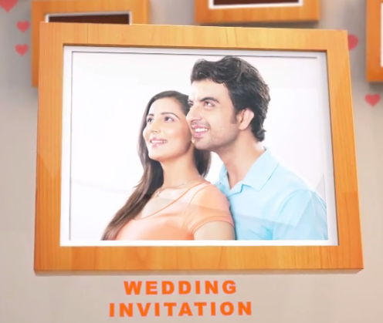 | Slide : 1 (Couple Photograph)  (High Resolution : Minimum 800 x 800 pixel)  Please rename your photograph with the name of Slide 1  Send your photograph by E-mail
  Wedding Invitation

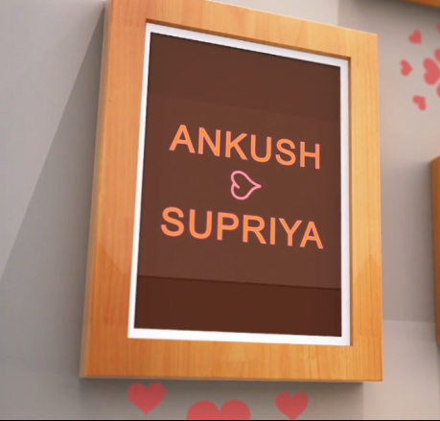 | Slide : 2 (Couple Name)
  Ankush
  Supriya

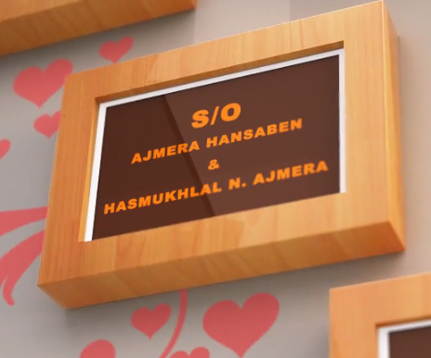 | Slide : 3 (Groom Parents Name)
  S/o. Hansaben Ajmera & Hasmukhlal M. Ajmera

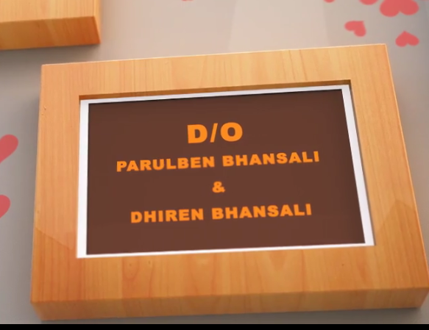 | Slide : 4 (Bride Parents Name)
  D/o. Parulben Bhansali & Dhiren Bhansali

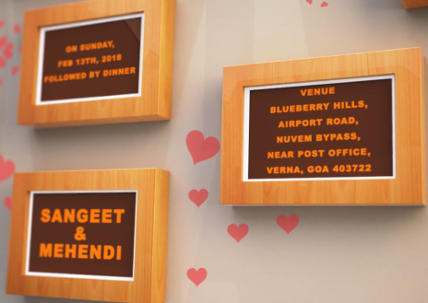 | Slide : 5 (Function Detail)  Function Name, Date, Time & Venue
  Sangeet & Mehendi
  on Saturday 13th Feb 2018
  6.30 pm onwards followed by dinner
  At Blue Berry Hill,
  Airport Road, Nuvem Bypass, Near Post Office, Venra,
  Goa - 403722

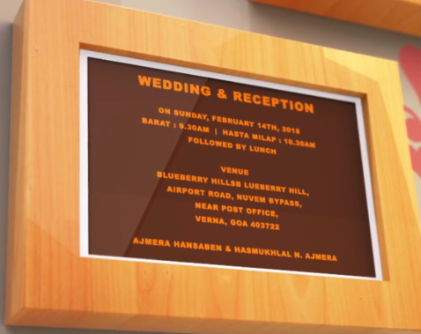 | Slide : 6 (Function Detail)  Function Name, Date, Time & Venue
  Wedding & Reception
  on Sunday 14th Feb 2018
  Baraat : 9.30 am | Hast Melap : 10.30 am
  Reception 12.00 pm onwards followed by lunch
  At Blue Berry Hill,
  Airport Road, Nuvem Bypass, Near Post Office, Venra,
  Goa - 403722
  Hansaben Ajmera & Hasmukhlal M. Ajmera

 | Slide : 7 (Save the date)  Date :
  14.02.2018

Video Music :
Same As or If any choice please send me Youtub Link by mail and Mention in form also.
Link :
https://www.youtube.com/watch?v=nIhijSP3MBc

