Video No. 1015
 | Slide No. 1  Wedding Invitation  Couple name
  Krisha & Yuvraj

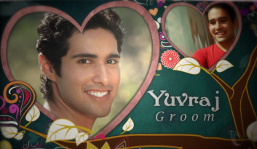 | Slide No. 2 (Groom Name & Photograph)  Groom Name  2 Photograph  (High Resolution : Minimum 800 x 800 pixel)  Please rename your photograph with the name of Slide 3  Send your photograph by E-mail
  Yuvraj

 | Slide No. 3 (Bride Name & Photograph)  Groom Name  2 Photograph  (High Resolution : Minimum 800 x 800 pixel)  Please rename your photograph with the name of Slide 3  Send your photograph by E-mail
  Yuvraj

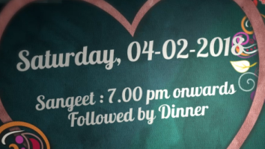 | Slide No. 4 (Function Detail)  Function name  Date  Time:
  Sangeet
  Saturday, 04.02.2018
  7.00 pm onwards followed by dinner

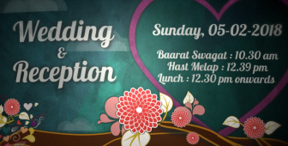 | Slide No. 5 (Function Detail)  Function name  Date  Time:
  Wedding & Reception
  Sunday, 05.02.2018
  Baarat Swagat : 10.30 am
  Hast Melap : 12.39 pm
  Lunch : 12.30 pm onwards

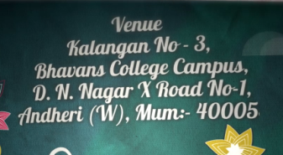 | Slide No. 5 (Venue Address)
  Venue :
  Kalangan No. 3, Bhavans College Campus, D N Nagar X Road No. 1, Andher (W), Mumbai – 400 05.

 | Slide No. 6 (Save the date)
  5.2.2018

Video Music :
Same As or If any choice please send me Youtub Link by mail and Mention in form also.
Link :
Same as

