Video No. P 1022
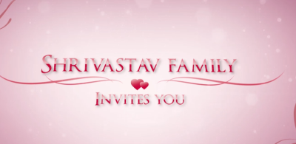 | Slide : 1 (Family name)  Invites You
  Shrivastav Family

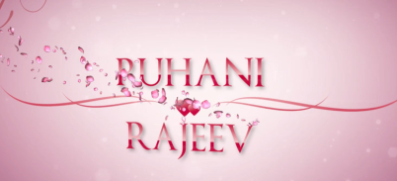 | Slide : 2 (couple name)
  Ruhani - Rajeev

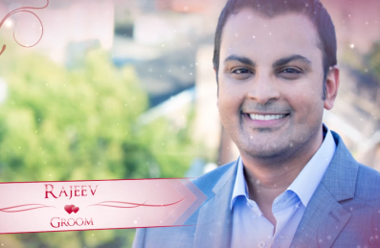 | Slide : 3 (Groom Photograph & name)  (High Resolution : Minimum 800 x 800 pixel)  Please rename your photograph with the name of Slide 3  Send your photograph by E-mail  Groom Name :  (If you are from bride side so first photo will come Bride photo and from groom side so first photo will come groom photo)
  Rajeev

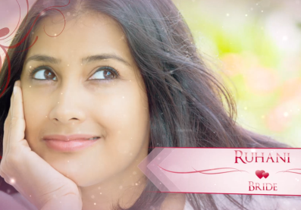 | Slide : 4 (Bride Photograph & name)  (High Resolution : Minimum 800 x 800 pixel)  Please rename your photograph with the name of Slide 3  Send your photograph by E-mail  Bride Name :
  Ruhani

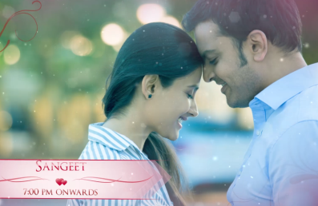 | Slide : 5 (Couple Photograph & Function detail)  (High Resolution : Minimum 800 x 800 pixel)  Please rename your photograph with the name of Slide 3  Send your photograph by E-mail  Function Detail
  Sangeet
  7.00 pm onwards

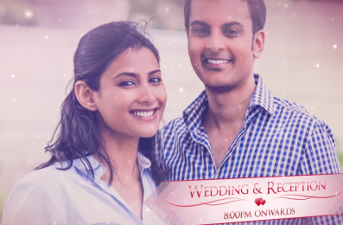 | Slide : 6 (Couple Photograph & Function detail)  (High Resolution : Minimum 800 x 800 pixel)  Please rename your photograph with the name of Slide 3  Send your photograph by E-mail  Function Detail
  Wedding & reception
  8.00 pm onwards

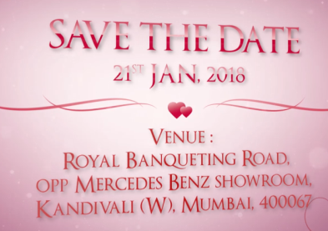 | Slide : 7 (Save the Date & Venue detail)  Save the Date  Venue
  21st jan. 2018
  Royal banqueting Road, Opp. Mercedes Benz Showroom, Kandivali (W), Mumbai – 67.

Video Music :
Same As or If any choice please send me Youtub Link by mail and Mention in form also.
Link :
Same As

