Video No. P 1023
 | Slide : 1 (Couple Photograph & Name)  (High Resolution : Minimum 800 x 800 pixel)  Please rename your photograph with the name of Slide 3  Send your photograph by E-mail  Couple name
  Diksha & Arnav

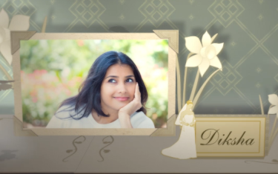 | Slide : 2 (Bride Solo Photograph & Name)  (High Resolution : Minimum 800 x 800 pixel)  Please rename your photograph with the name of Slide 3  Send your photograph by E-mail  Bride name
  Diksha

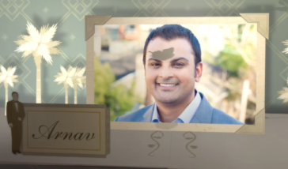 | Slide : 3 (Groom Solo Photograph & Name)  (High Resolution : Minimum 800 x 800 pixel)  Please rename your photograph with the name of Slide 3  Send your photograph by E-mail  Groom name
  Arnav

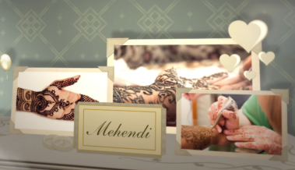  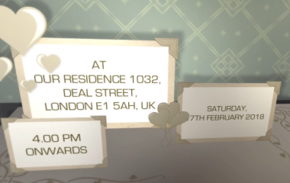 | Slide : 4 (Function name)
  Mehendi
  Saturday, 7th Feb. 2018
  4.00 pm onwards
  At our Residence, 1032, Deal Street London E1 5AH UK.

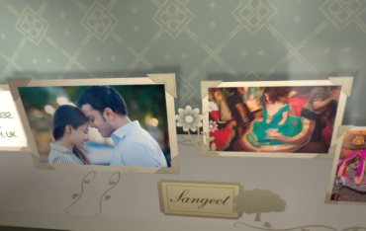  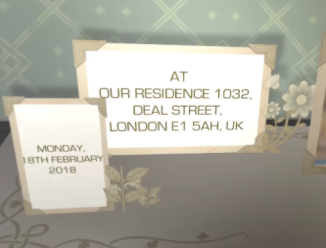 | Slide : 5 (Function name & Couple Photograph)  (High Resolution : Minimum 800 x 800 pixel)  Please rename your photograph with the name of Slide 3  Send your photograph by E-mail
  Sangeet
  Monday, 9th Feb. 2018
  7.00 pm onwards
  At our Residence, 1032, Deal Street London E1 5AH UK.

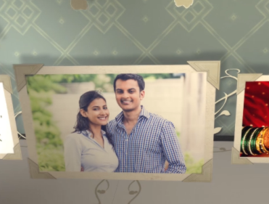  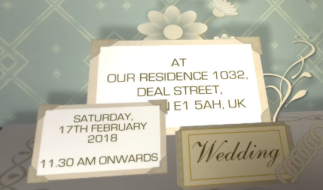 | Slide : 6 (Function name & Couple Photograph)  (High Resolution : Minimum 800 x 800 pixel)  Please rename your photograph with the name of Slide 6  Send your photograph by E-mail
  Wedding
  Wednesday, 11th Feb. 2018
  11.30 am onwards
  At our Residence, 1032, Deal Street London E1 5AH UK.

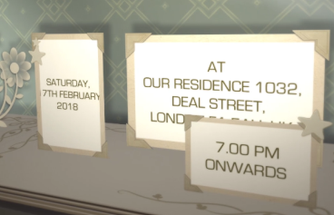 | Slide : 7 (Function name)
  Reception
  Wednesday, 11th Feb. 2018
  7.00 pm onwards
  At our Residence, 1032, Deal Street London E1 5AH UK.

Slide : 8 (couple Photograph & Save the Date)
(High Resolution : Minimum 800 x 800 pixel)
Please rename your photograph with the name of Slide 3
Send your photograph by E-mail

Save the Date :
11.2.2018

Video Music :
Same As or If any choice please send me Youtub Link by mail and Mention in form also.
Link :
Same As

