Video No. P 1026
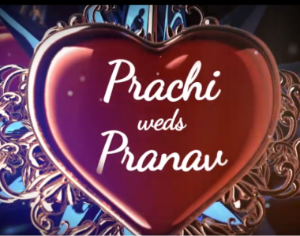 | Slide : 1 (Couple Name)  Couple name
  Prachi weds Pranav

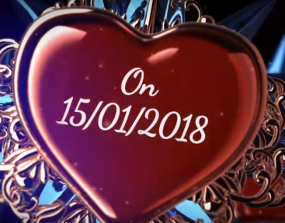 | Slide : 2 (Date)  Date
  On 15.01.2018

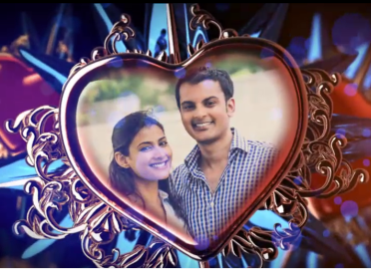 | Slide : 3 (Couple Photograph)  (High Resolution : Minimum 800 x 800 pixel)  Please rename your photograph with the name of Slide 3  Send your photograph by E-mail

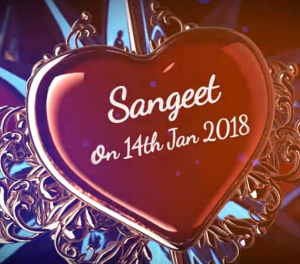 | Slide : 4 (Function detail)  Sangeet  On 14th Jan 2018

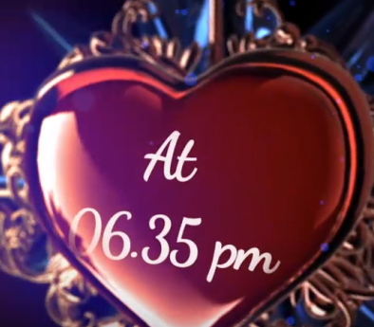 | Slide : 5 (Function detail)  Sangeet  6.35 pm

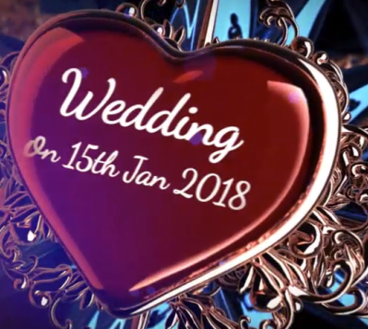 | Slide : 6 (Function detail)  Wedding  On 15th Jan 2018

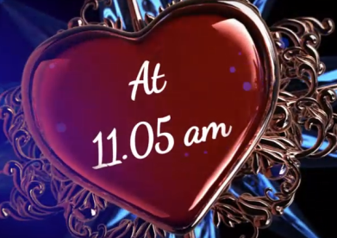 | Slide : 7 (Function detail)  Wedding  At 11.05 am

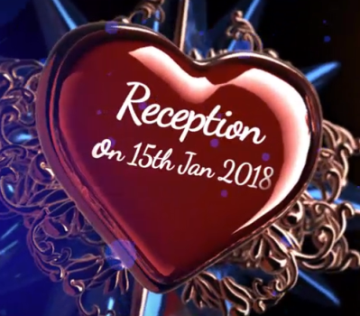 | Slide : 8 (Function detail)  Reception  On 15th Jan 2018

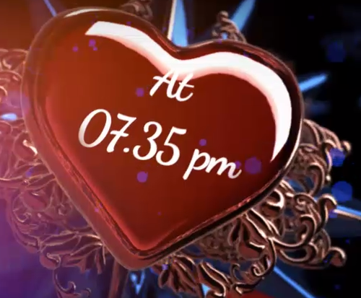 | Slide : 9 (Function detail)  Reception  At 07.35 pm

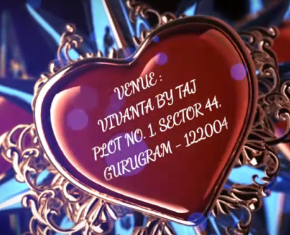 | Slide : 9 (Venue)
  Vivanta By Taj
  Plot No. 1, Sector 44, Gurugram - 122004

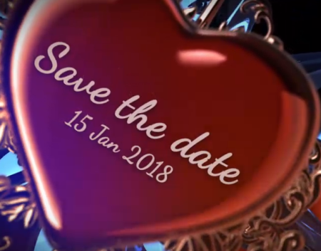 | Slide : 10 (Save the Date)
  15th Jan 2018

Video Music :
Same As or If any choice please send me Youtub Link by mail and Mention in form also.
Link :
Same As

