Video No. P1033
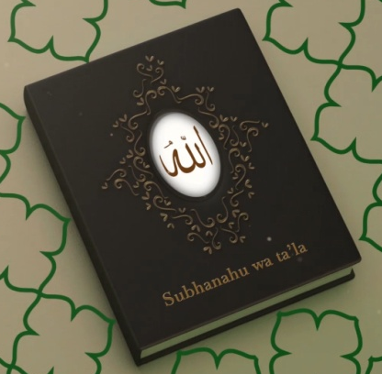 | Slide No. 1  Subhanahu wa ta’la

Slide No. 2 (Two Lovers )
Couple Photograph
(High Resolution : Minimum 800 x 800 pixel)
Please rename your photograph with the name of Slide 1
Send your photograph by E-mail

Slide No. 3 ( Who Become A Bride)
Bride Solo Photograph
(High Resolution : Minimum 800 x 800 pixel)
Please rename your photograph with the name of Slide 3
Send your photograph by E-mail

Slide No. 4 ( and a handsome Groom)
Groom Solo Photograph
(High Resolution : Minimum 800 x 800 pixel)
Please rename your photograph with the name of Slide 3
Send your photograph by E-mail

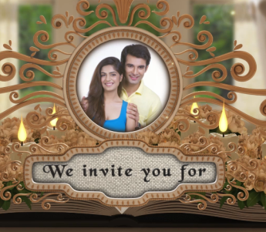 | Slide No. 5 (We Invite you for)  Couple Photograph  (High Resolution : Minimum 800 x 800 pixel)  Please rename your photograph with the name of Slide 3  Send your photograph by E-mail

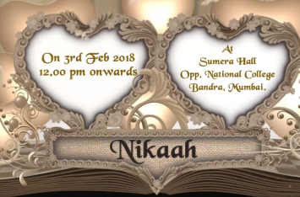 | Slide No. 6 (Nikaah Date, Time & Venue)  Date  Time :  Venue :
  On 03rd Feb. 2018
  At 12.00 pm
  At Sumera Hall
  Opp. National College
  Bandra, Mumbai.

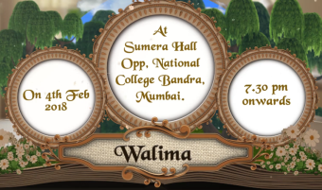 | Slide No. 7 (Walima Date, Time & venue)  Walima  Date  Time :  Venue :
  On 04th Feb. 2018
  At 7.30 pm
  At Sumera Hall
  Opp. National College
  Bandra, Mumbai.

Slide No. 8 (Save the Date)
03rd Feb. 2018

Video Music :
Same As or If any choice please send me Youtub Link by mail and Mention in form also.
Link :
https://www.youtube.com/watch?v=nIhijSP3MBc

