Video No. P 1034
 | Slide : 1 (Couple name)  Nikah of
  Shabana & Salman

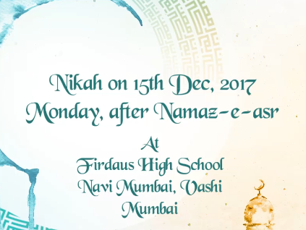 | Slide : 2 (Date & Venue)  Nikah on 15th Dec, 2017  Monday, after Namaz – E – asr  At  Firdaus High School  Navi Mumbai, Vashi, Mumbai.

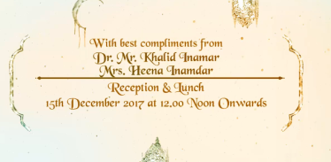 | Slide : 3  With best compliments from  Reception & lunch
  Dr. Mr. Khalid Inamdar
  Mrs. Heena Inamdar
  15th December 2017 at 12.00 noon onwards

Video Music :
Same As or If any choice please send me Youtub Link by mail and Mention in form also.
Link :
Same As

