Video No. P 1035
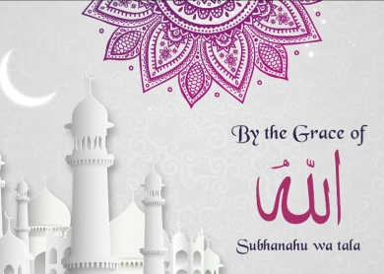 | Slide : 1  By the grace of  Subhanahu Wa tala

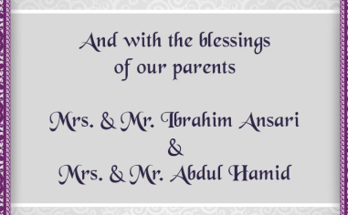 | Slide : 2  And with the blessings of our parents  Groon Parents name  Bride Parents Name
  Mrs. & Mr. Ibrahim Ansari
  Mrs. & Mr. Abdul Hamid

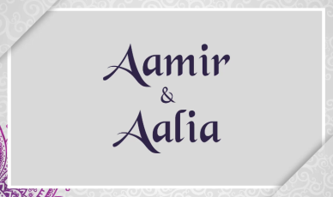 | Slide : 3  Couple Name
  Aamir & Aalia

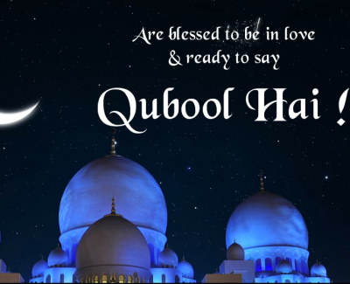 | Slide : 4  Are blessed to be in love & ready to say  Qubool hai!

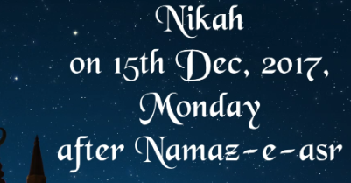 | Slide : 5  Nikah
  Monday, On 15th Dec,2017
  After Namaz - e - asr

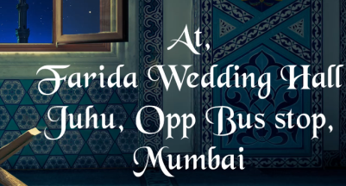 | Slide : 6  Venue
  At, Farida Wedding Hall
  Juhu, Opp Bus Stop, Mumbai.

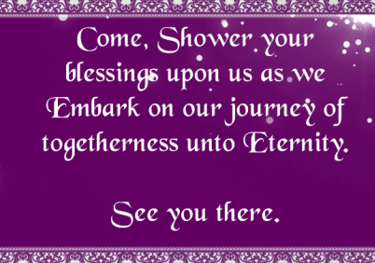 | Slide : 7  Come, Shower your blessings upon us as we Embark on our journey of togetherness unto Eternity.  See you there.

Video Music :
Same As or If any choice please send me Youtub Link by mail and Mention in form also.
Link :
Same As

