Video No. P 1029
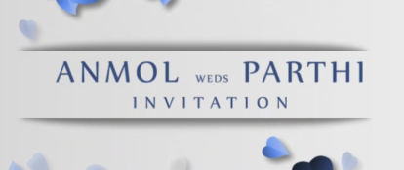 | Slide : 1  Couple Name  Invitation
  Anmol weds Parthi

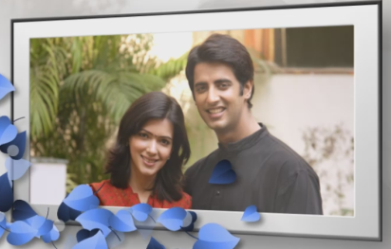 | Slide : 2 (Couple Photograph)  (High Resolution : Minimum 800 x 800 pixel)  Please rename your photograph with the name of Slide 2  Send your photograph by E-mail

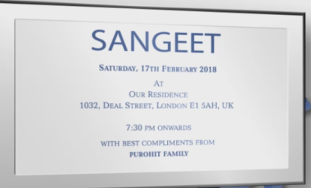 | Slide : 3 (Function Detail)  Sangeet
  Saturday, 17th February 2018
  At or residence, 1032, Deal Street, London E1 SAH, UK.
  7.30 pm onwards
  With best compliments from
  Purohit Family

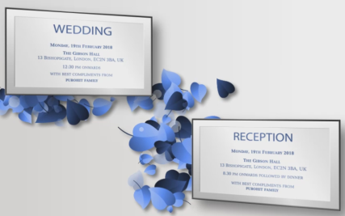 | Slide : 4 (Function Detail)  Wedding  Reception
  Monday, 19th February 2018
  At or residence, 1032, Deal Street, London E1 SAH, UK.
  12.30 pm onwards
  With best compliments from
  Purohit Family
  Monday, 19th February 2018
  At or residence, 1032, Deal Street, London E1 SAH, UK.
  8.30 pm onwards
  With best compliments from
  Purohit Family

 | Slide : 5  Save the date
  19.02.2018

Video Music :
Same As or If any choice please send me Youtub Link by mail and Mention in form also.
Link :
Same As

