Video No. P 1024
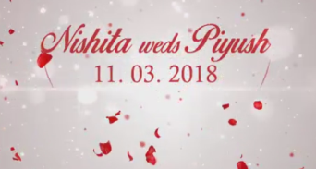 | Slide : 1 (Couple Name & Date)  Couple name  Date :
  Nishita weds Piyush
  11.03.2018

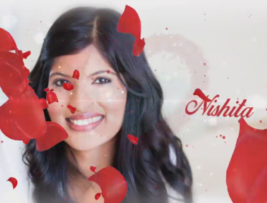 | Slide : 2 (Bride Photograph & Name)  (High Resolution : Minimum 800 x 800 pixel)  Please rename your photograph with the name of Slide 2  Send your photograph by E-mail  Bride name
  Nishita

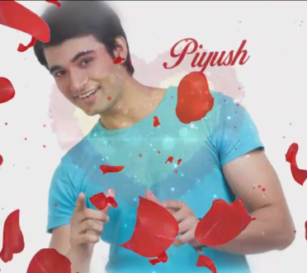 | Slide : 3 (Groom Photograph & Name)  (High Resolution : Minimum 800 x 800 pixel)  Please rename your photograph with the name of Slide 3  Send your photograph by E-mail  Groom name
  Piyush

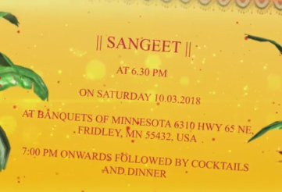 | Slide : 4 (Function detail)  Function name  Date  Venue  Time
  Sangeet
  On Saturday, 10.03.2018
  At banquets of Minnesota 6310 HWY 65 NE, Fridley, MN 55432, USA.
  7.00 pm onwards followed by cocktails and dinner

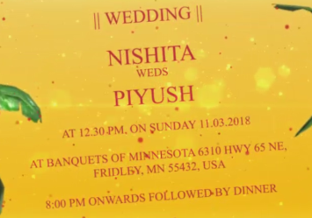 | Slide : 5 (Function detail)  Function name  Couple name  Date  Venue  Time
  Wedding
  Nishita weds Piyush
  On Sunday, 11.03.2018, 12.30 pm
  At banquets of Minnesota 6310 HWY 65 NE, Fridley, MN 55432, USA.
  8.00 pm onwards followed by dinner

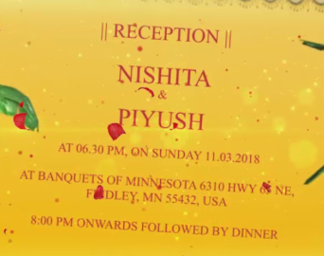 | Slide : 6 (Function detail)  Function name  Couple name  Date  Venue  Time
  Reception
  Nishita & Piyush
  On Sunday, 11.03.2018, 6.30 pm
  At banquets of Minnesota 6310 HWY 65 NE, Fridley, MN 55432, USA.
  8.00 pm onwards followed by dinner

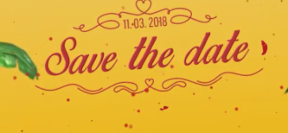 | Slide : 7 (Save the date)
  11.03.2018

Video Music :
Same As or If any choice please send me Youtub Link by mail and Mention in form also.
Link :
Same As

